**PRIORITY_QUEUE in C++ STL:**



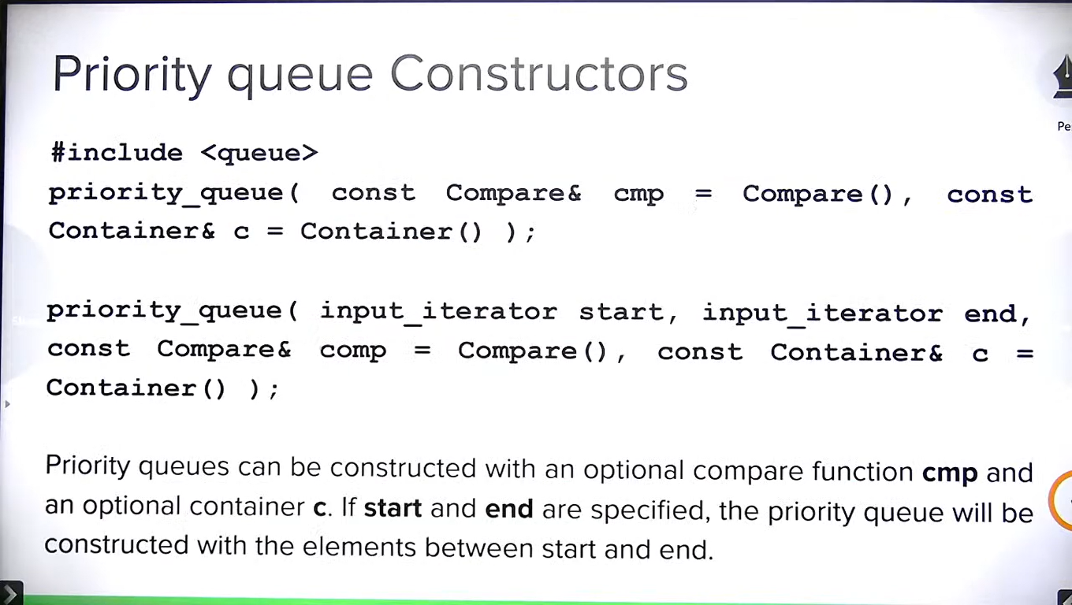

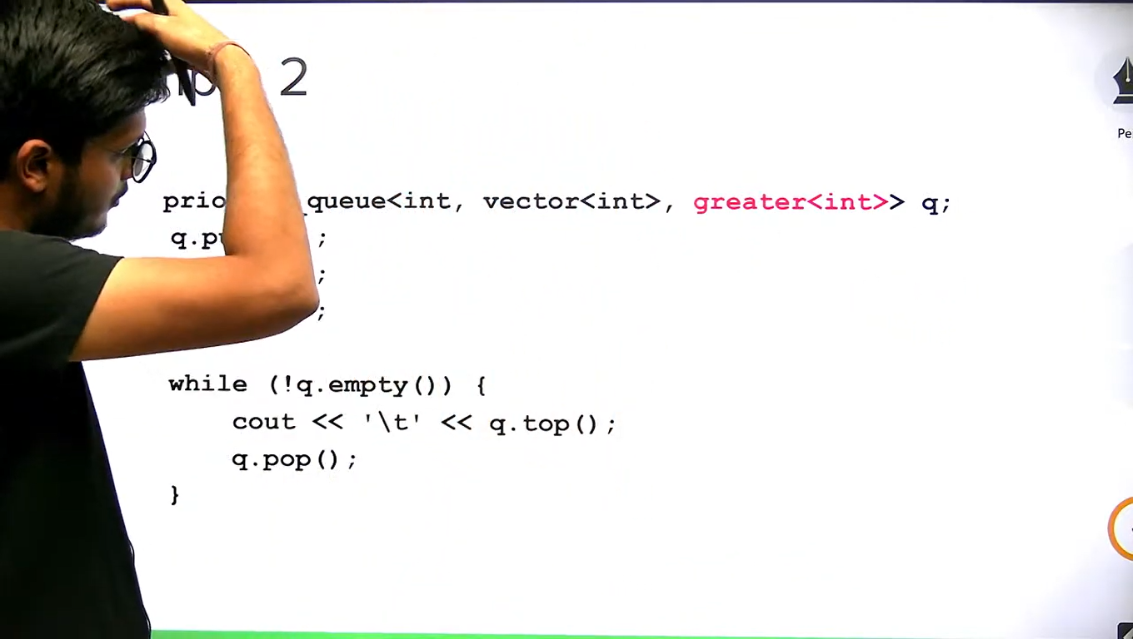

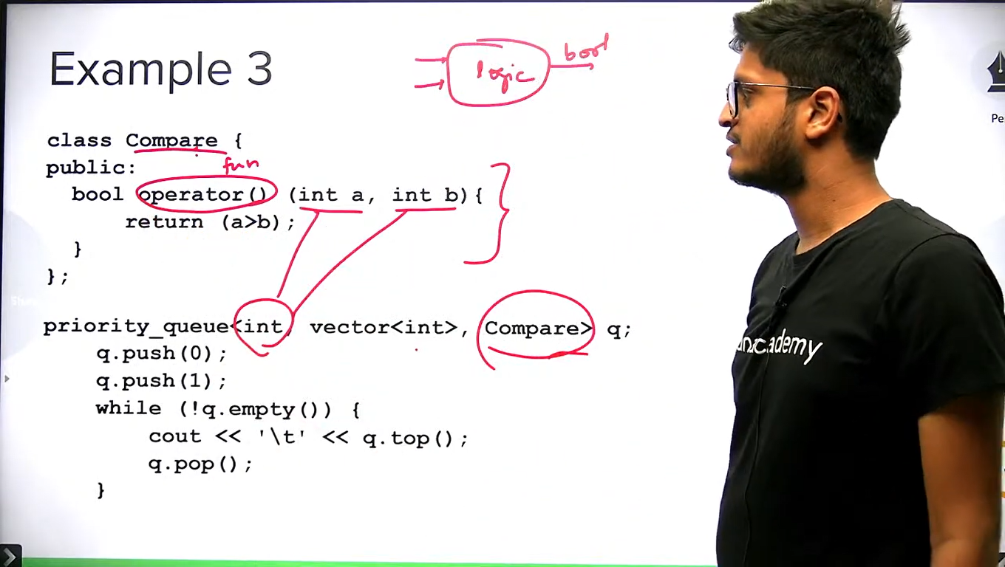

**For_each() In C++ STL:**

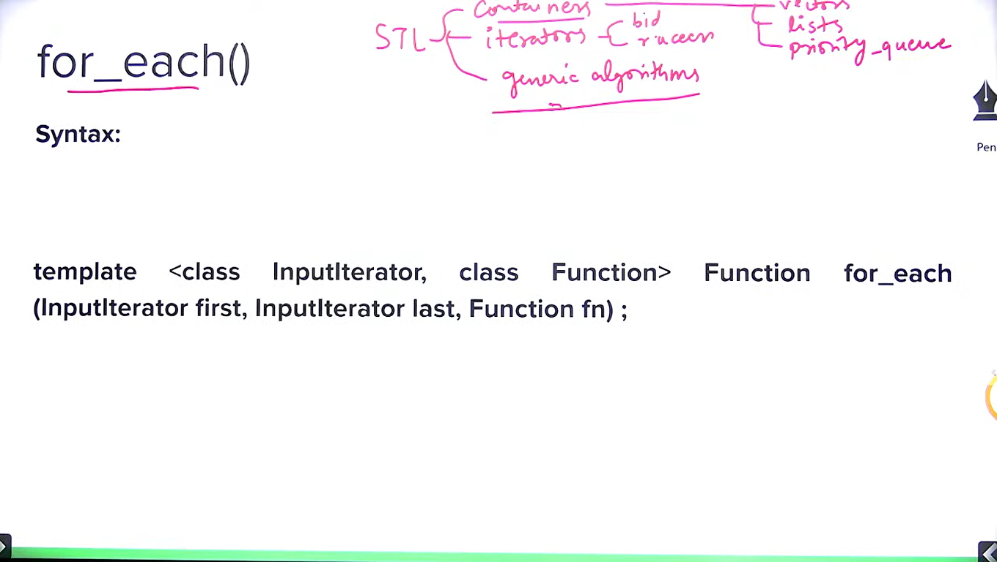

**Note:** It uses unary function. Unary/binary functions accepts one/two elements of a data type and returns any data type after doing some operation. When it returns bool, it becomes predicate.

Function and predicates are different. Predicates return bool always. Comparator is binary predicate.

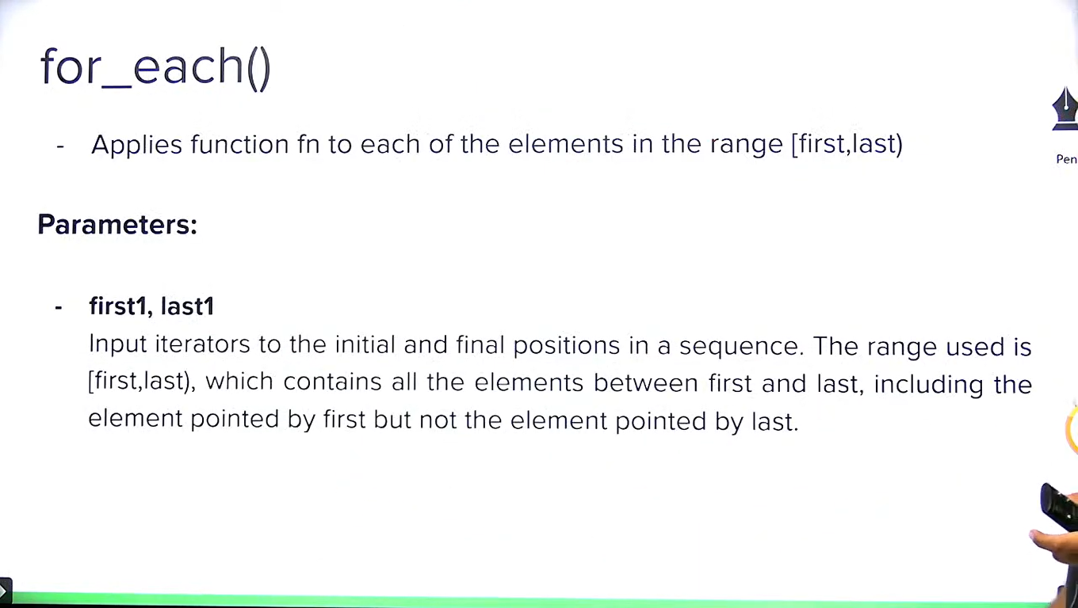

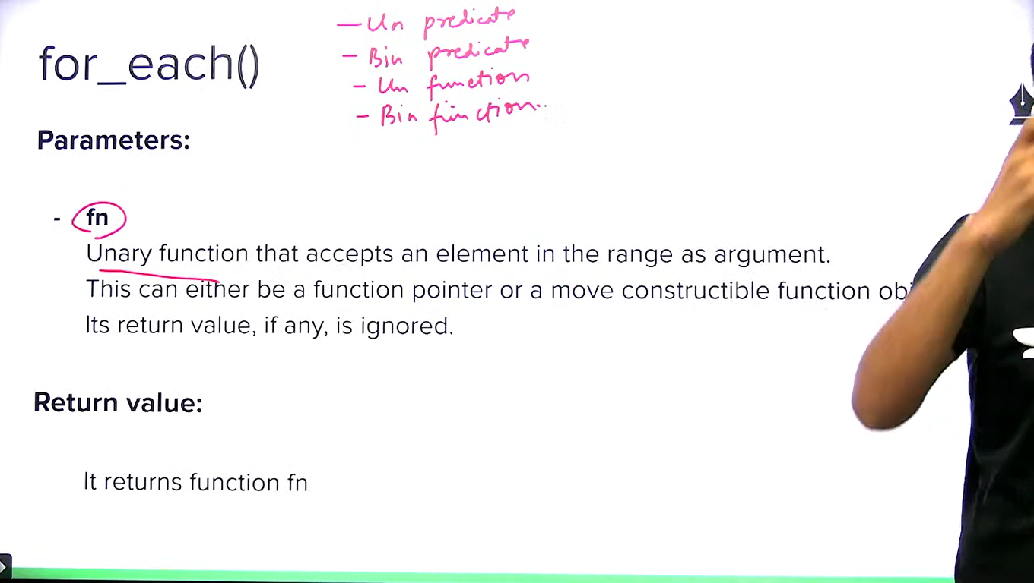

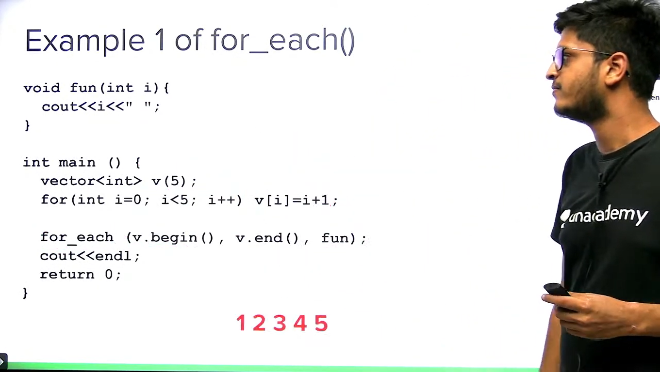

**Note:** We can create a function/predicate using struct/class with overloading () operator.

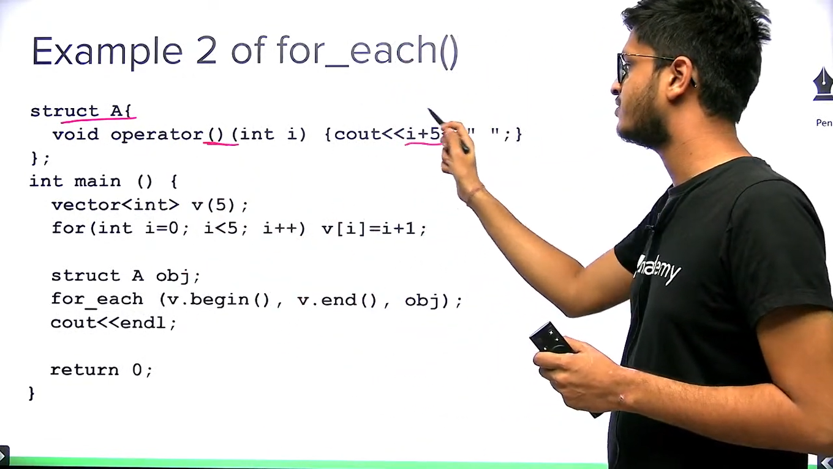

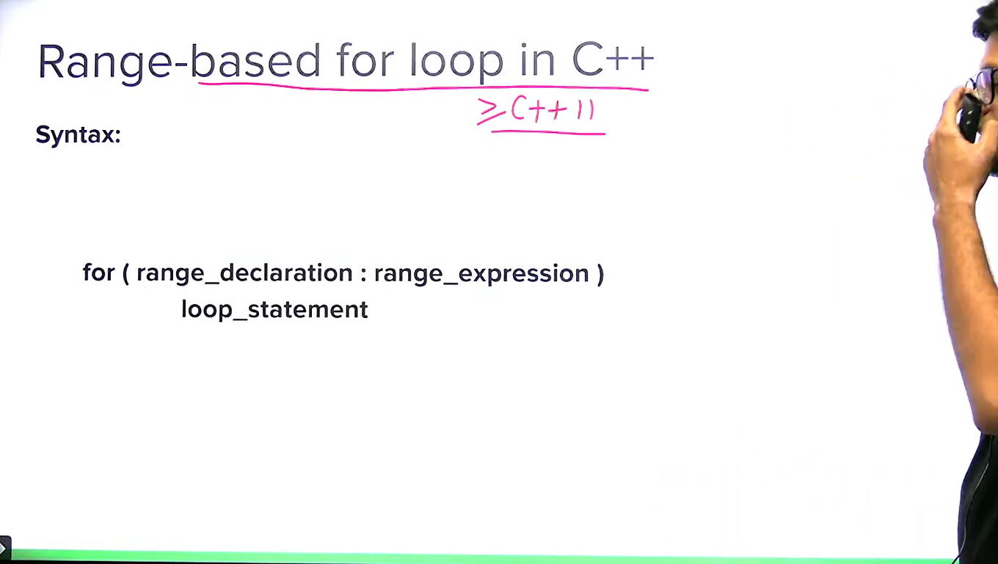

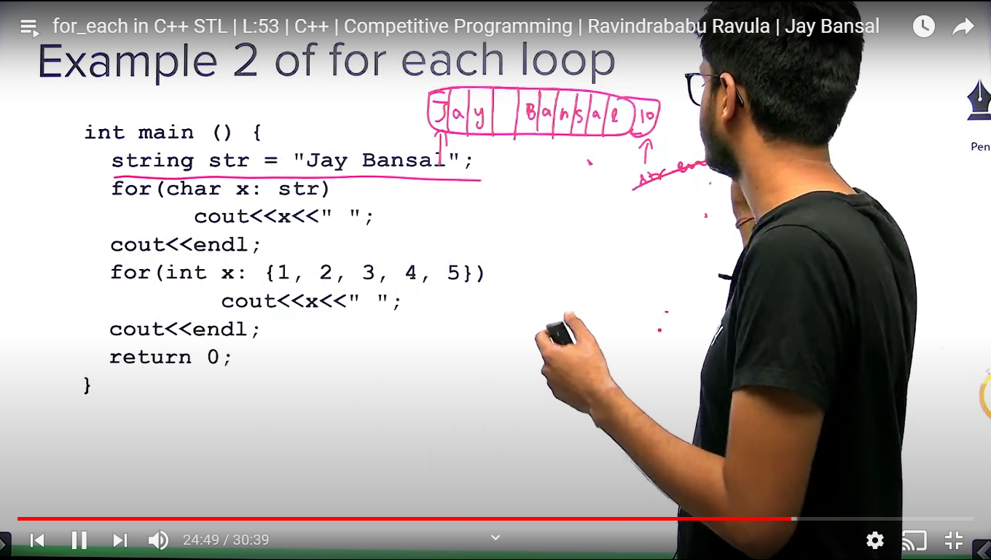

**Note:** Difference between for_each() and range based for loop :

In for_each(), we can control the range of operation because [first, last) iterator is passed though range based for loop is applied on all the elements of containers.

**Max, max_element, min, min_element in C++ STL :**

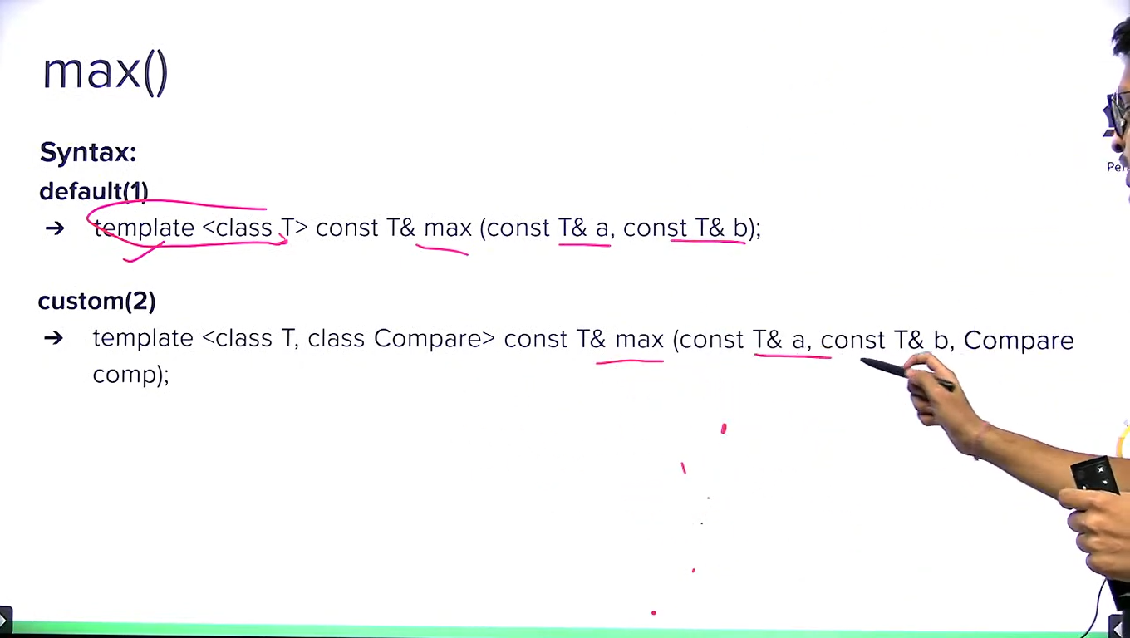

**Note:** comparator is used when we obtain max of two custom objects or pair objects etc.

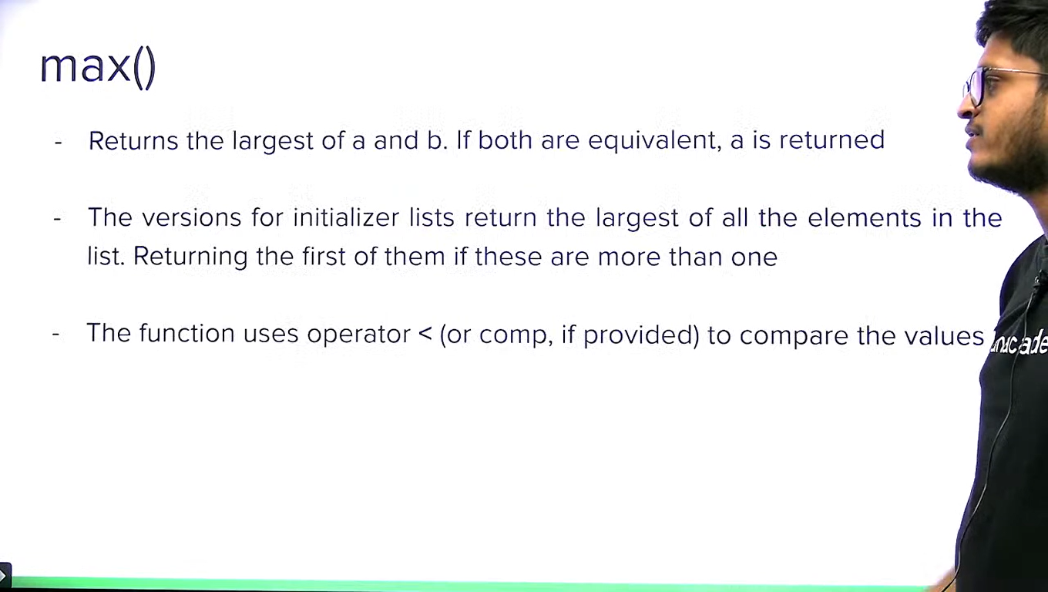

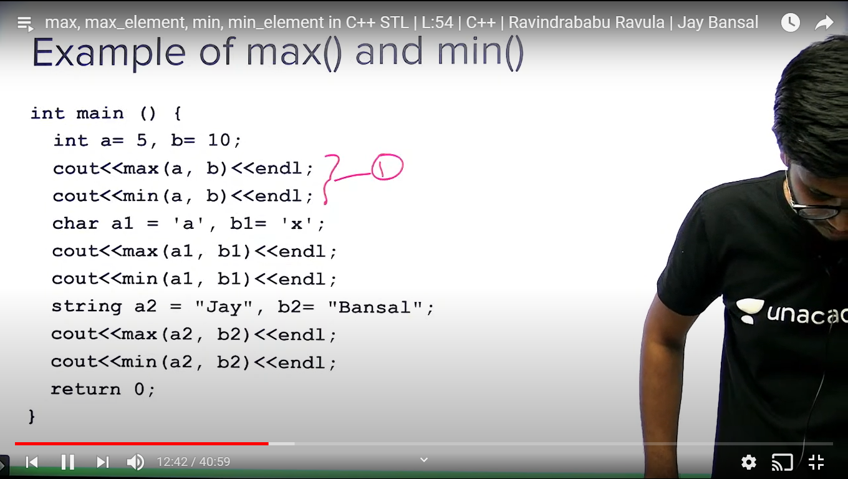

**Note:** max of three elements = max(a, max(b,c));

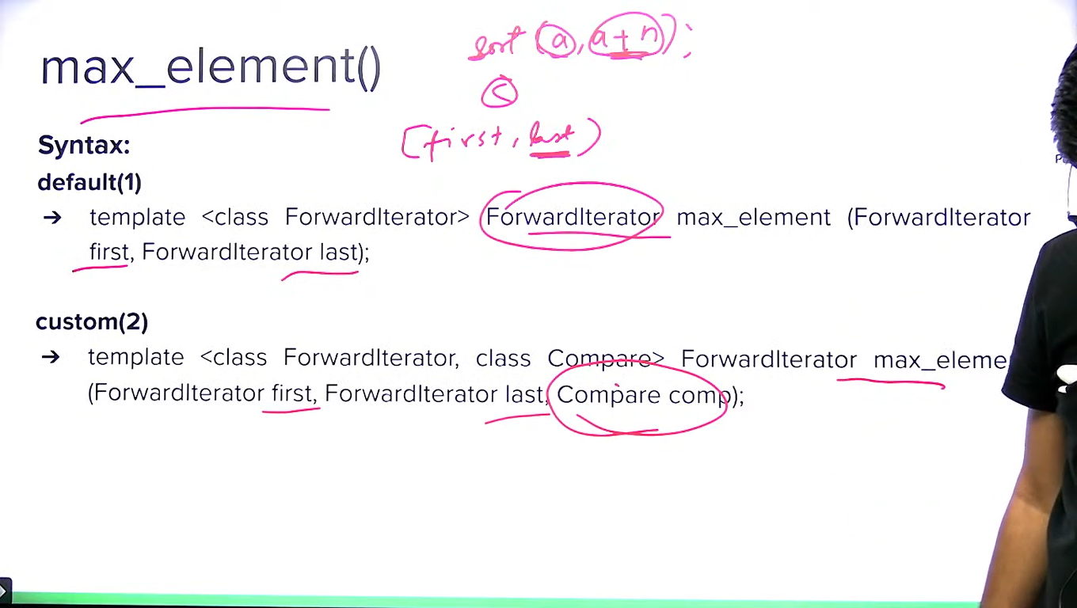

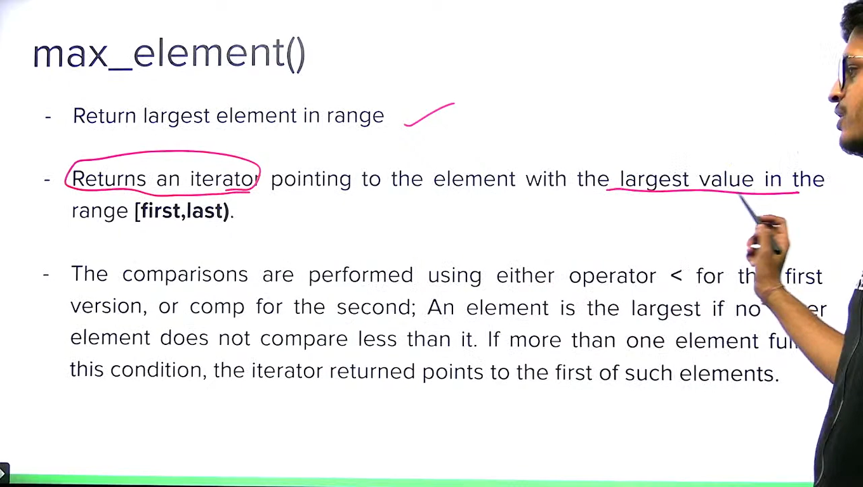

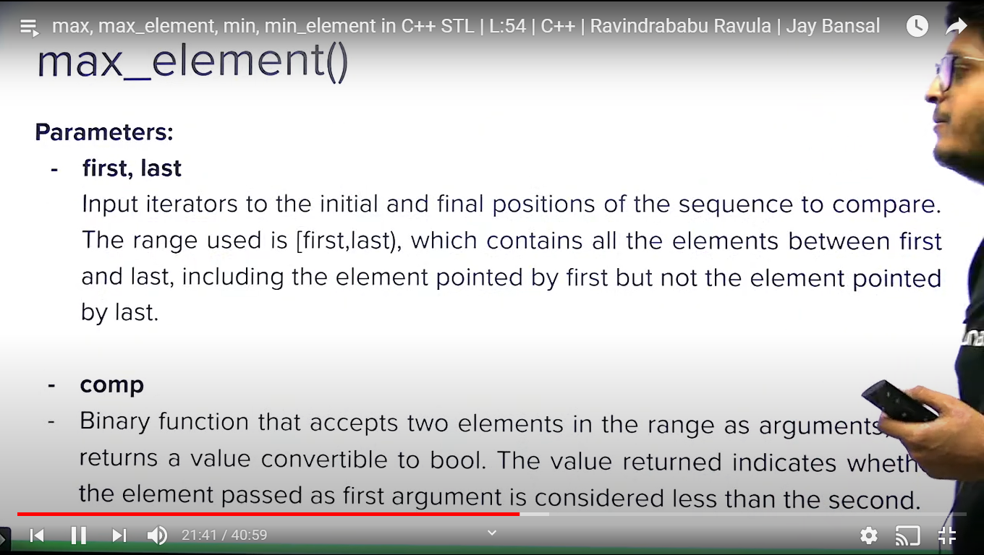

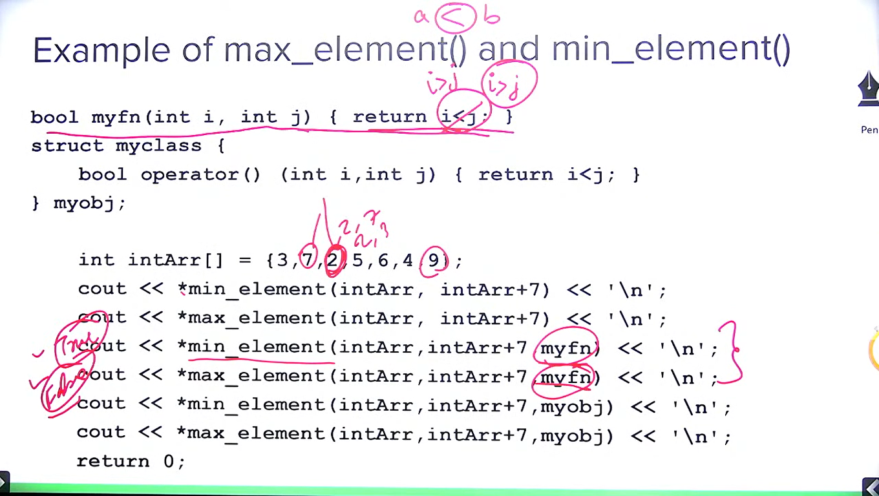

**Note:** default comparator is < . If we change < by > then min element will become max element and vice versa.

**Adjascent_difference() in C++ STL:**

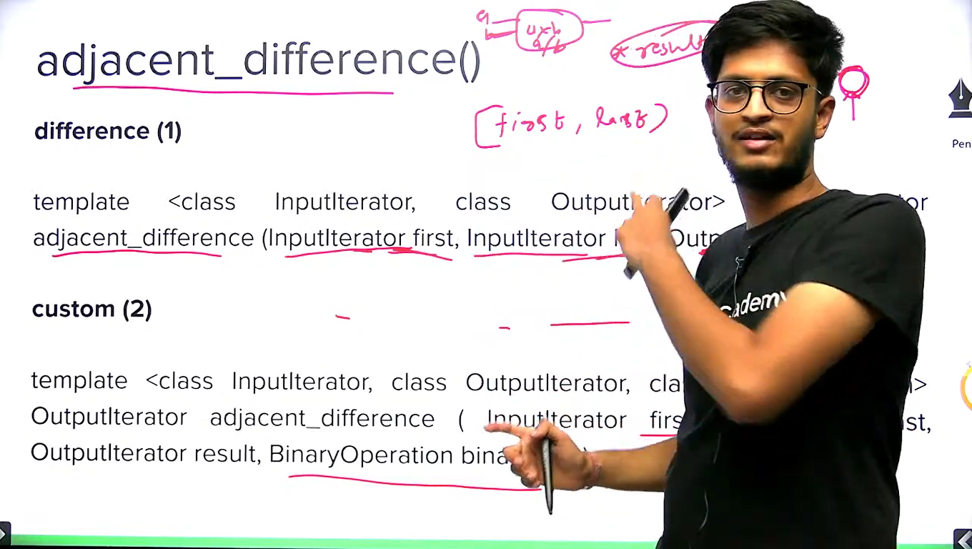

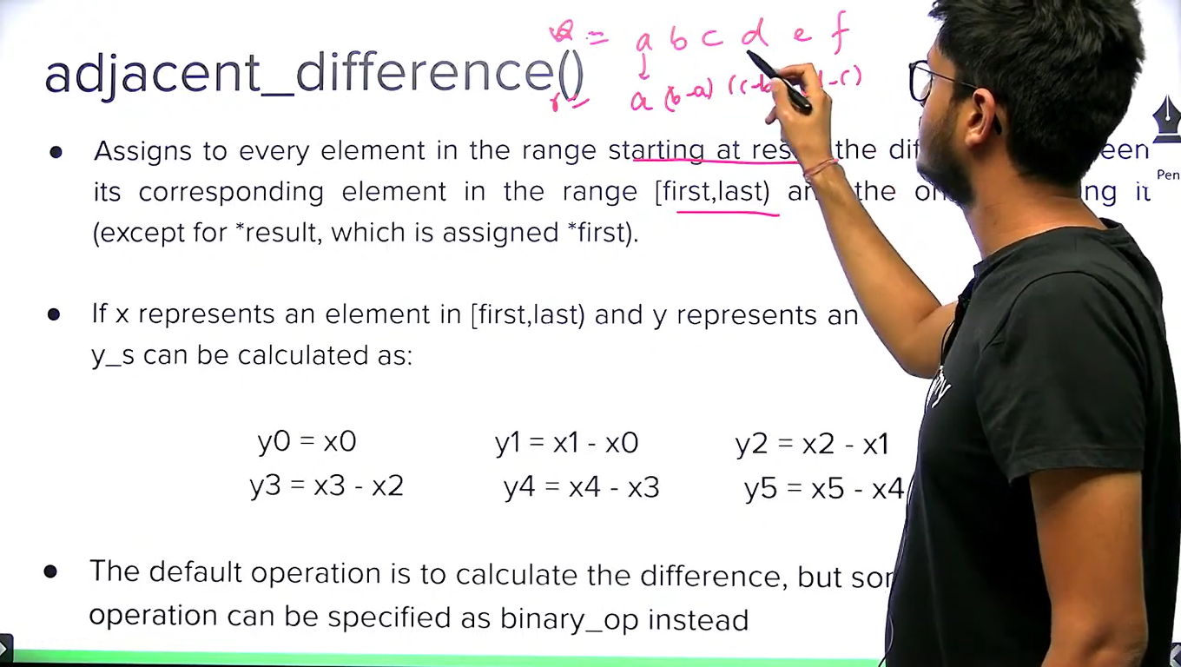

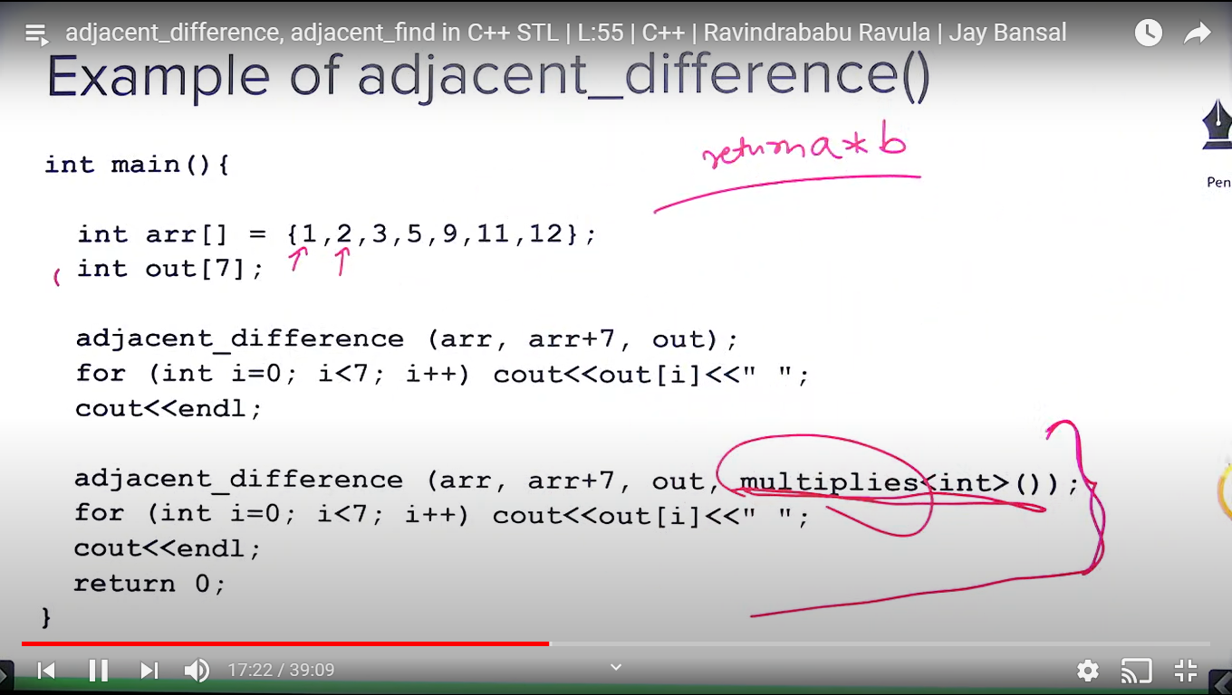

**Deque in C++ STL:**



**Note:** vector doesn’t have push_front() and pop_front().

Deque provides inserting/deleting data from both end in O(1) time.

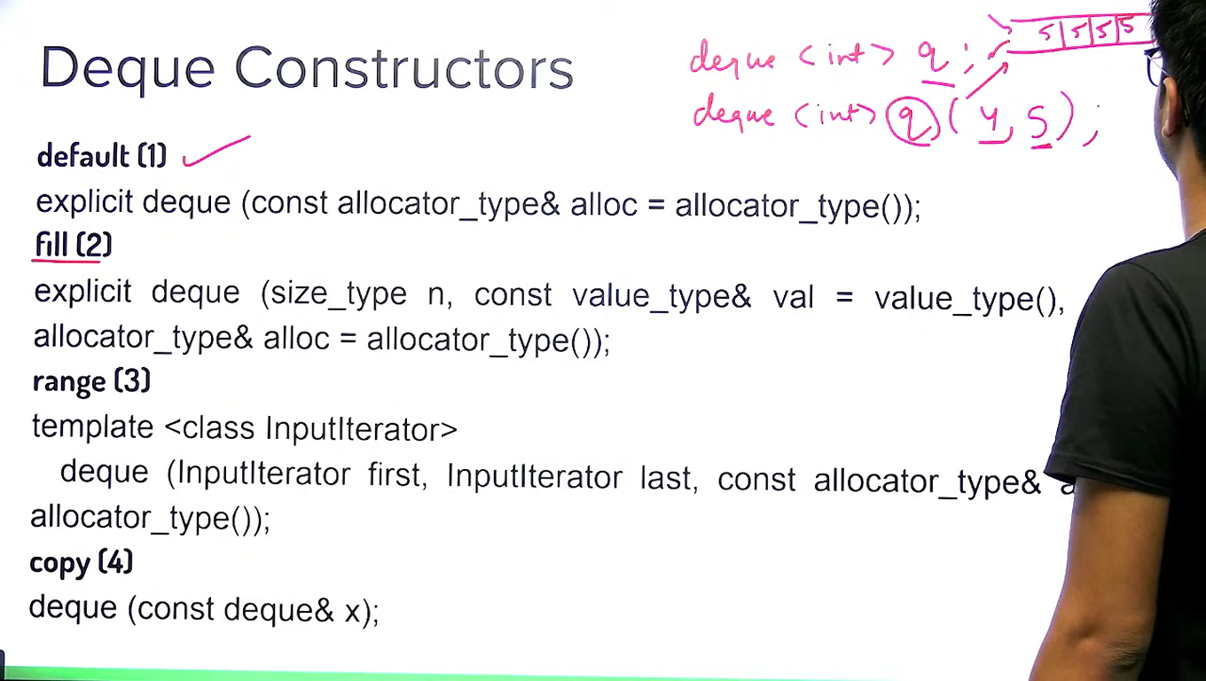

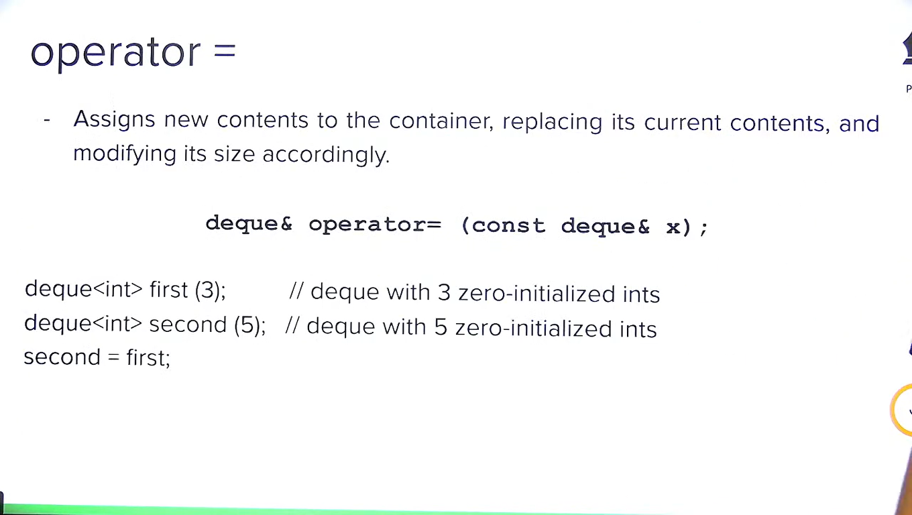

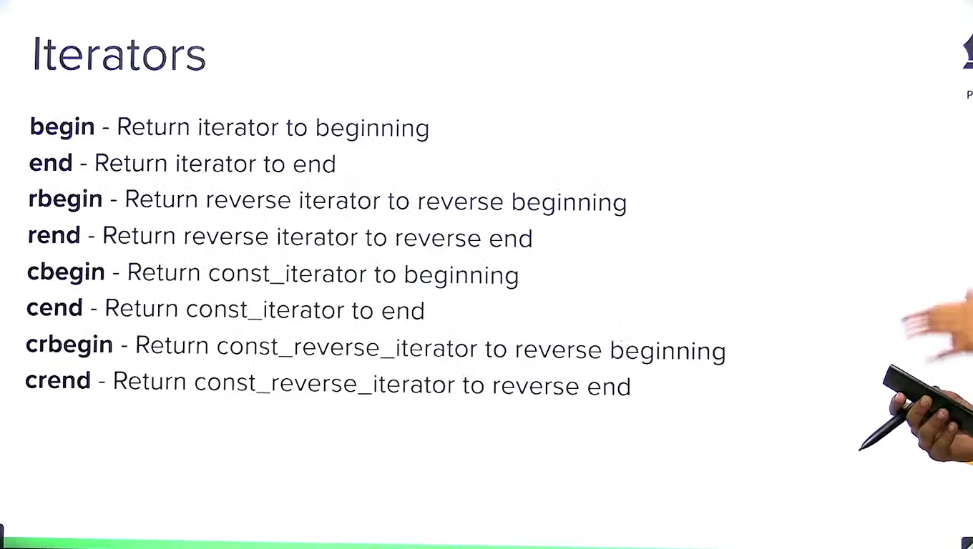

C means constant.

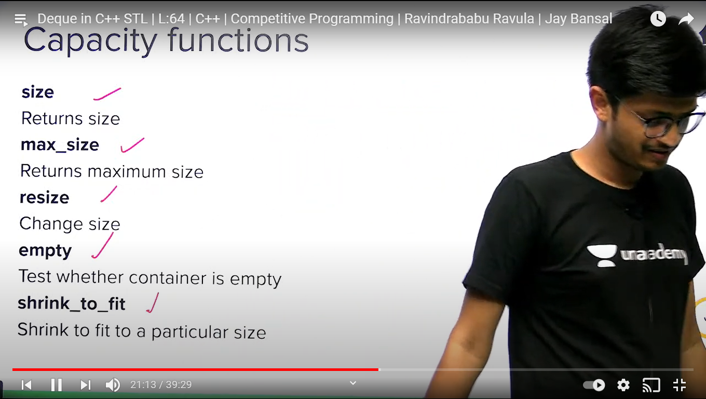

Shrink_to_fit is used to make the capacity and size equal.

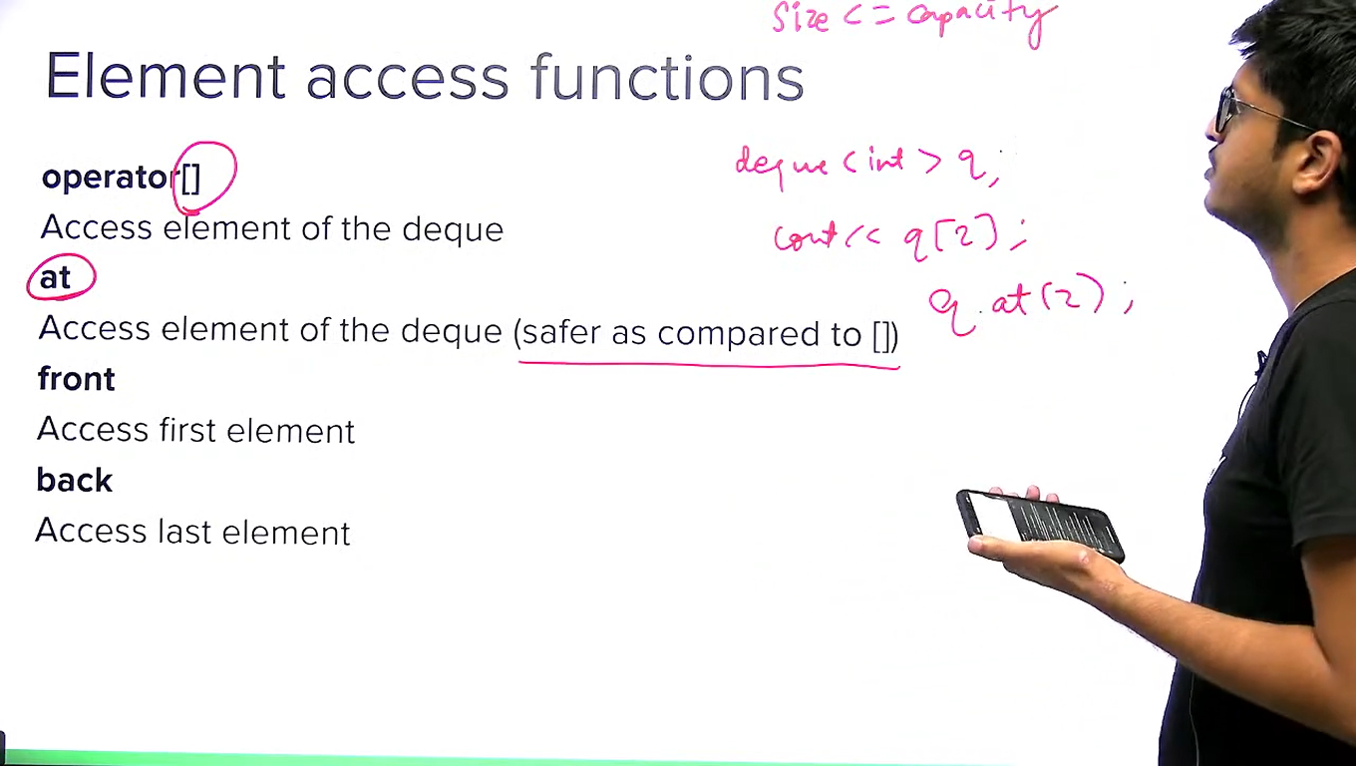

Similar to vector, deque also supports erase by using iterator and range of iterator only not by value.

**Set and Multi-Sets in C++ STL:**

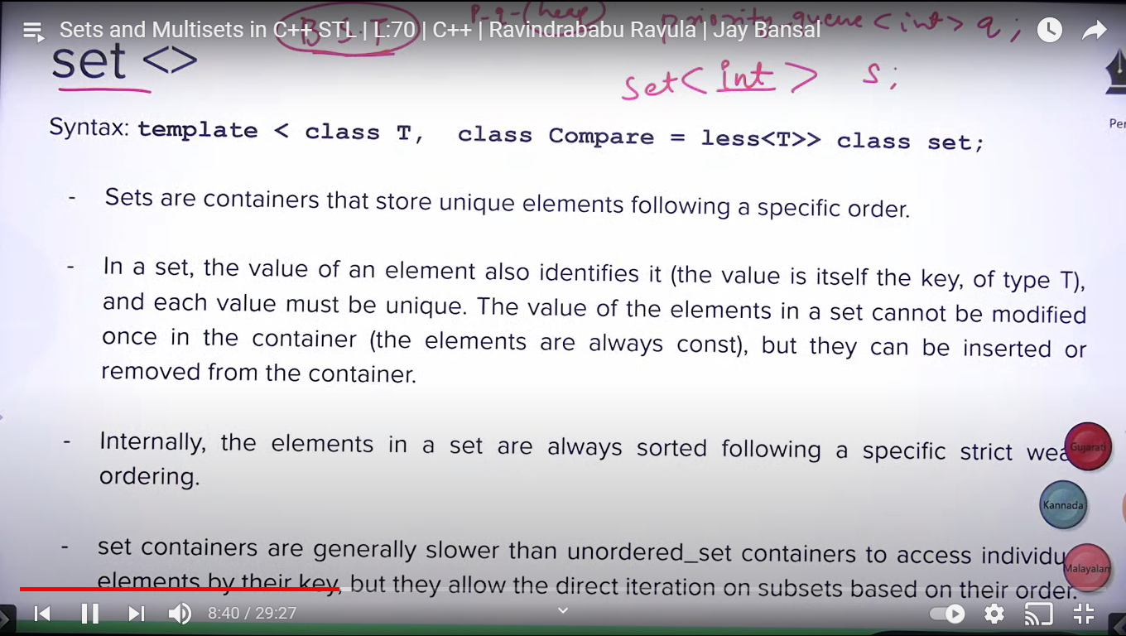

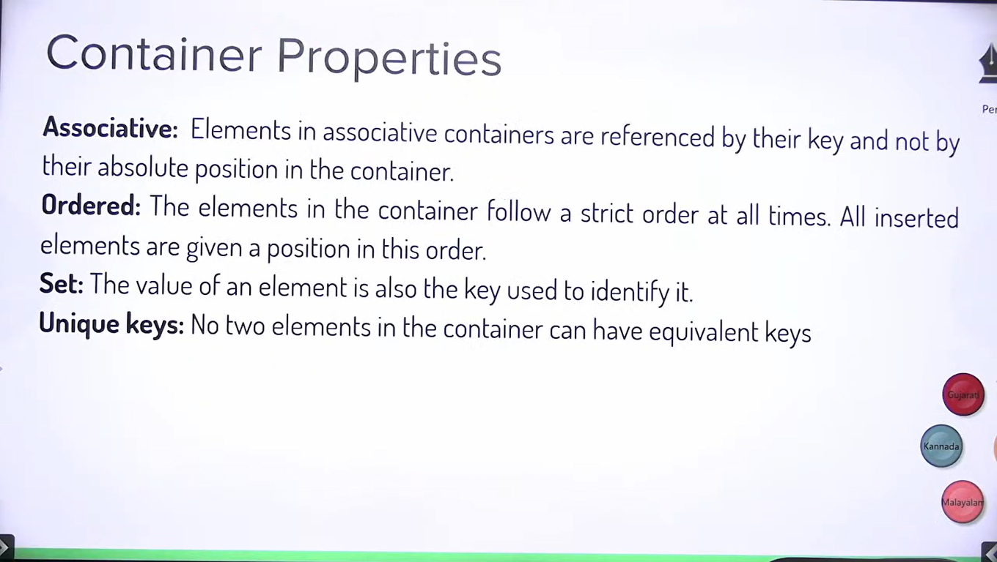

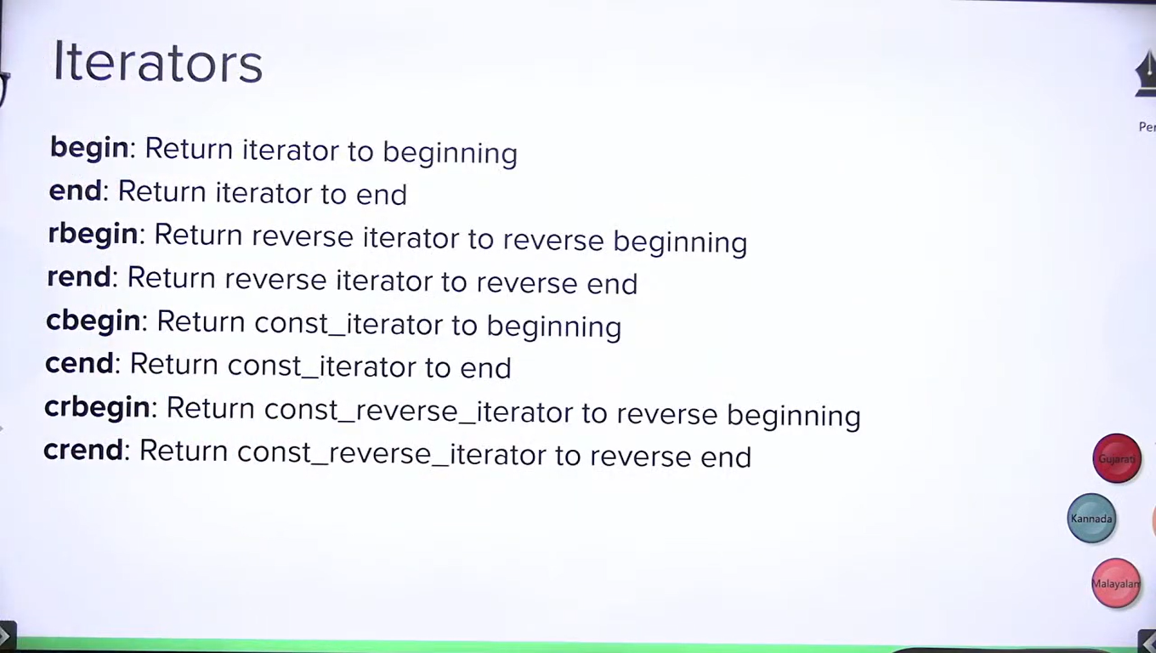

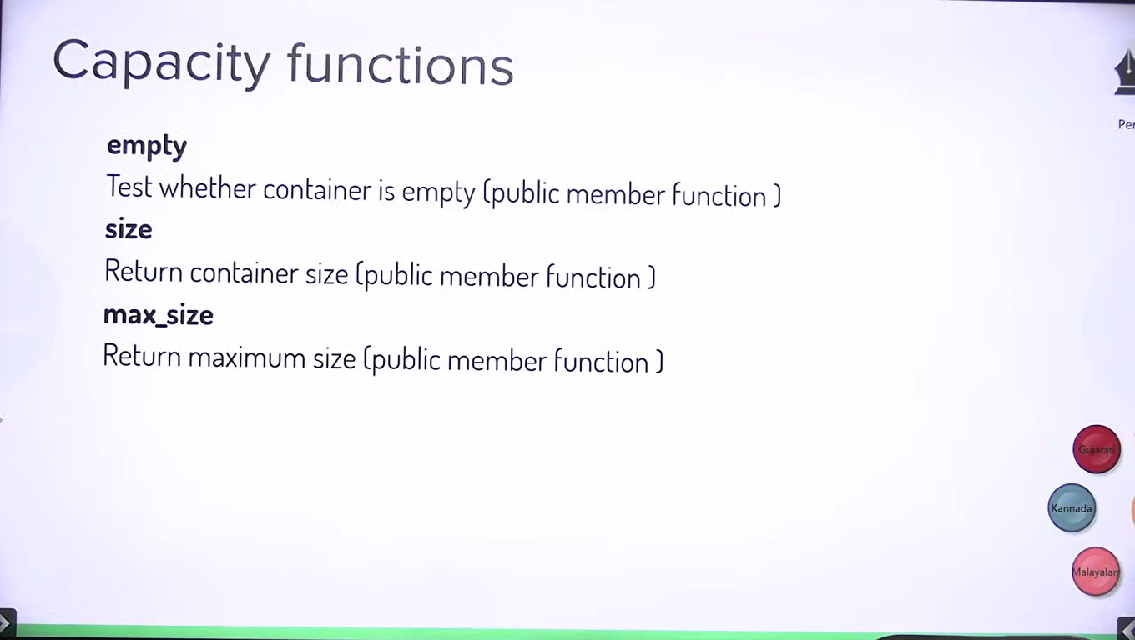

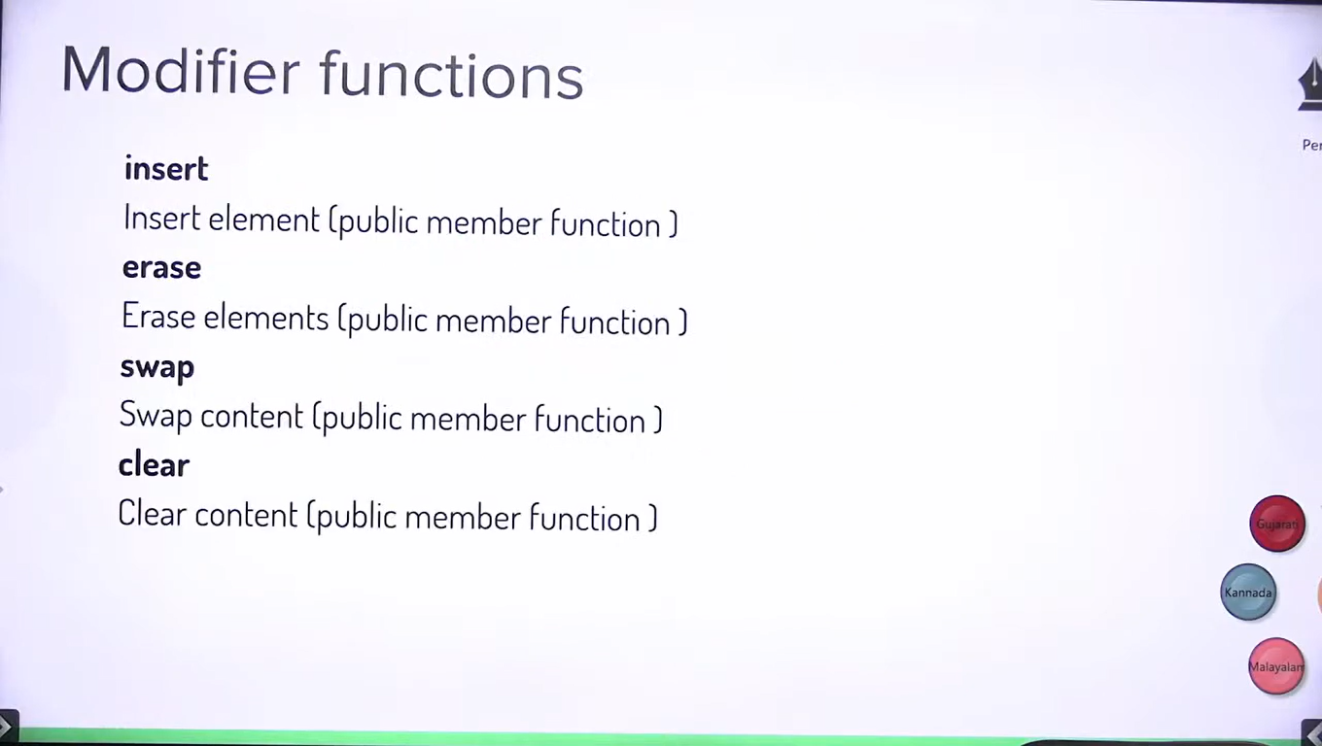

**Note:** Unlike vector, deque, we can erase element here using val, iterator and range of two iterators.

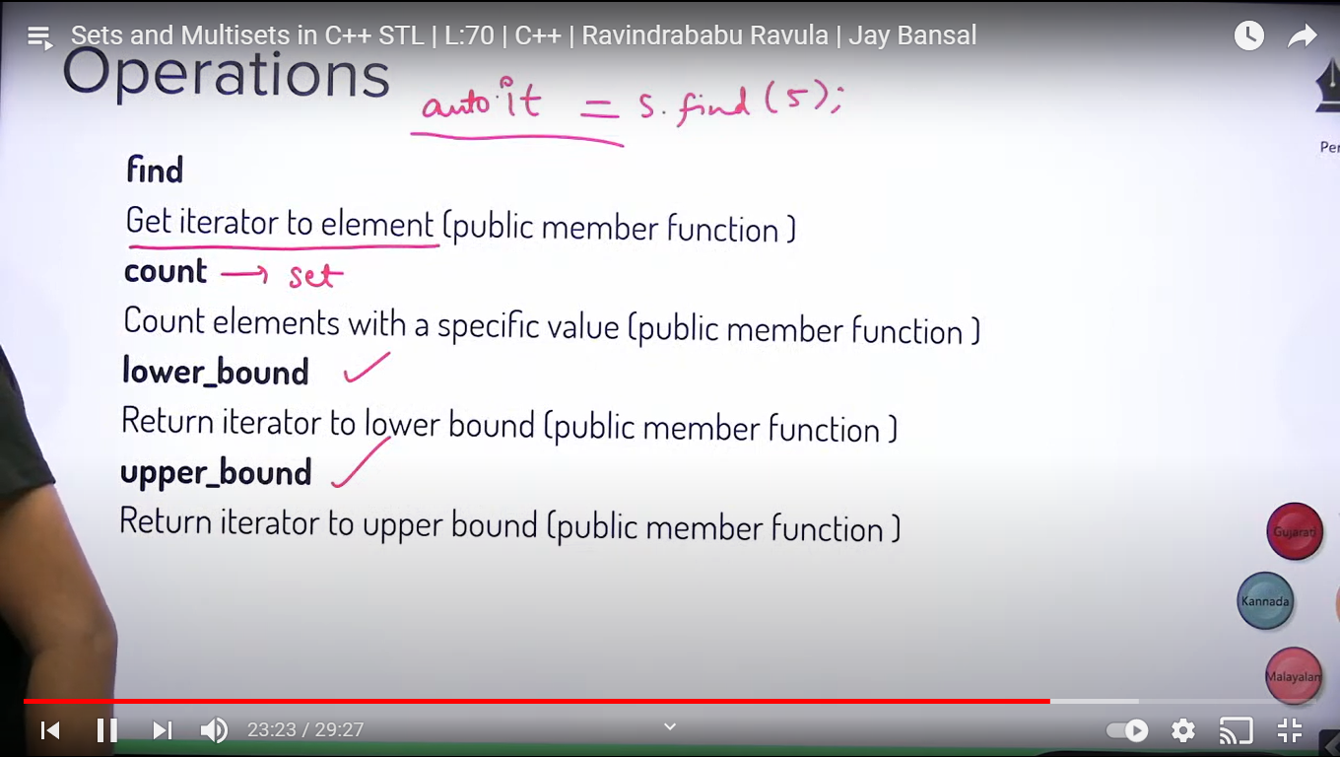

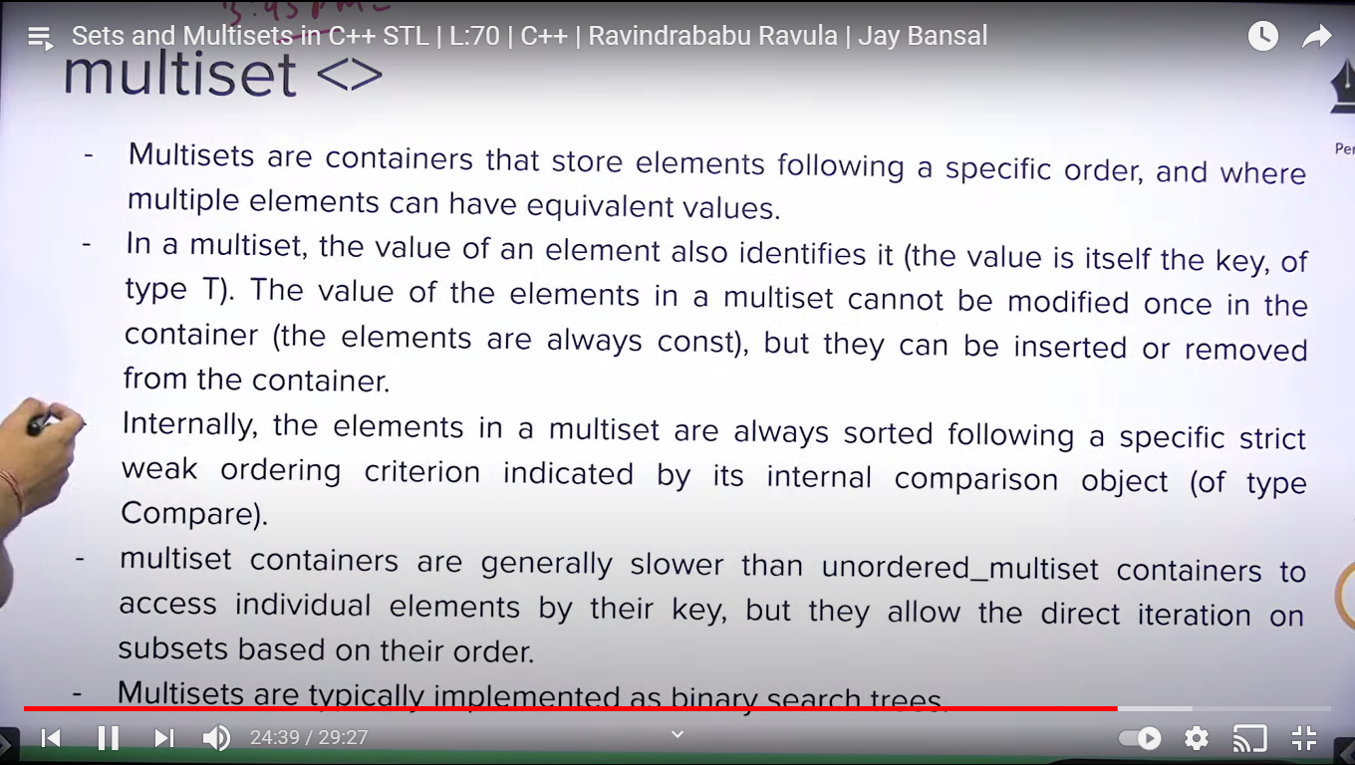

**Note**: map/multimap is similar to set/multiset. Only difference is map stores key/value pair.

**How to achieve fast input/out in C++. Specially in competitive programming :**

